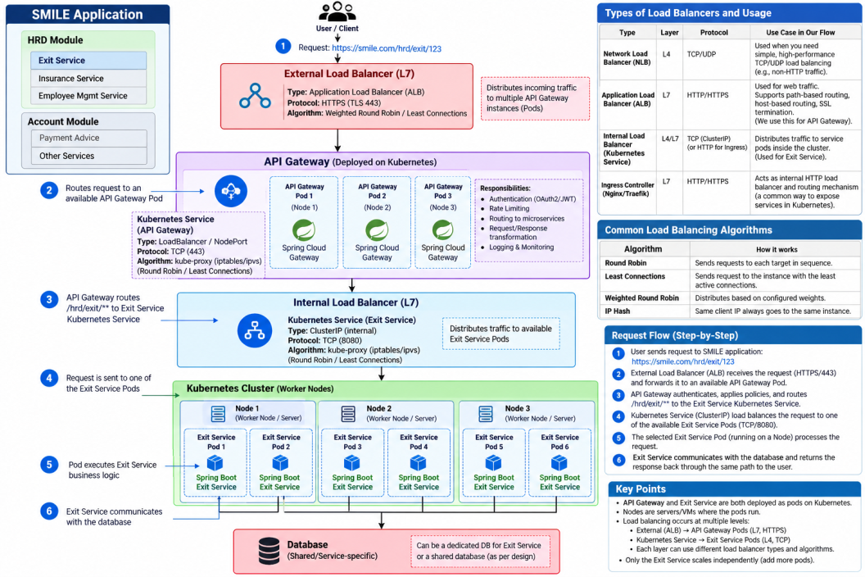

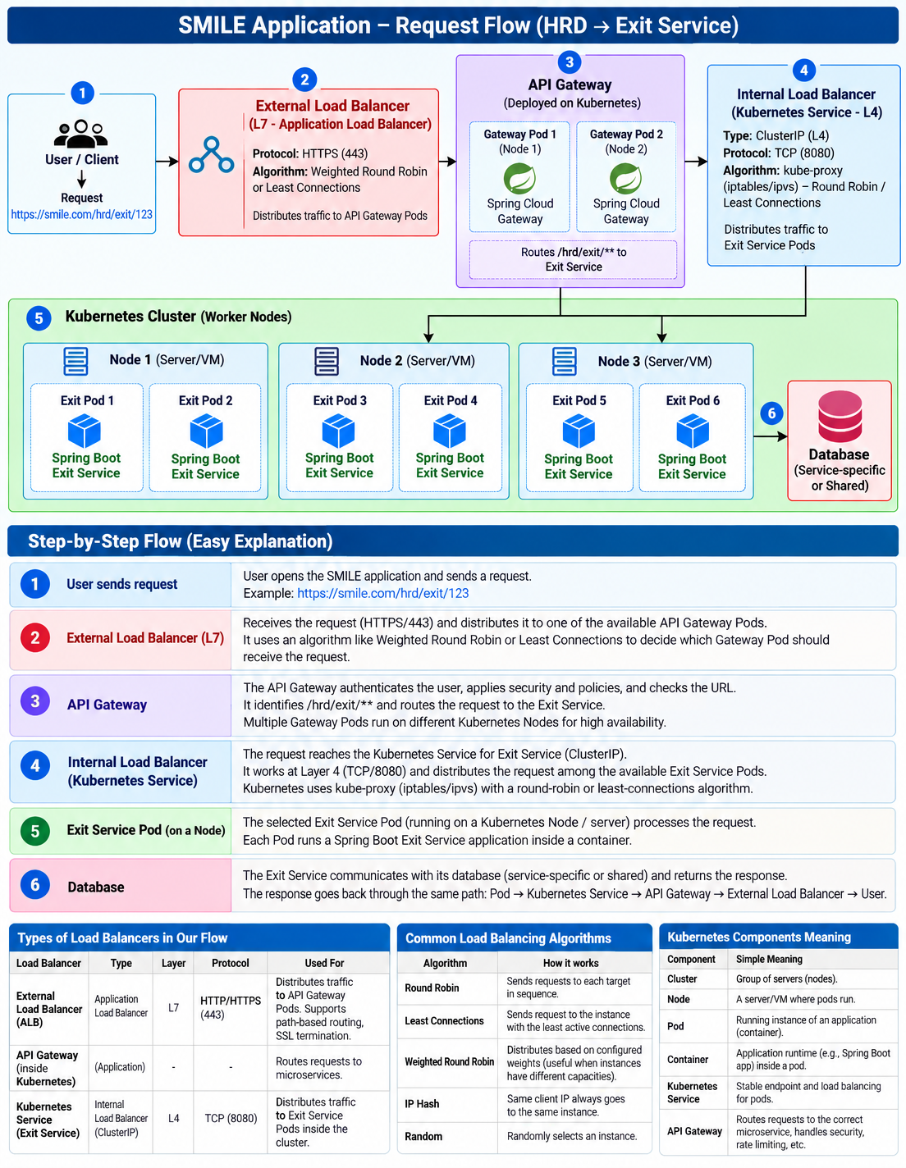
Absolutely. I’ll keep the same simple flow you liked and add the missing IP + Port + L4 traffic part.

SMILE → HRD → Exit Service — Complete Flow
Suppose the user sends:
GET /hrd/exit/123

1. Complete picture
USER
|
| GET /hrd/exit/123
↓
+---------------------------+
| EXTERNAL LOAD BALANCER |
| L7 |
| HTTP / HTTPS |
+---------------------------+
|
| chooses Gateway
↓
+---------------------------+
| API GATEWAY |
| L7 |
| Understands the URL |
+---------------------------+
|
| /hrd/exit/**
| → Exit Service
↓
+---------------------------+
| KUBERNETES SERVICE |
| Exit Service |
| L4 |
| TCP / IP / Port |
+---------------------------+
|
| chooses Exit Pod
↓
+--------------------------------+
| KUBERNETES CLUSTER |
| |
| +--------------+ |
| | Node 1 | |
| | Server / VM | |
| | | |
| | +----------+ | |
| | | Exit Pod | | |
| | | 1 | | |
| | +----------+ | |
| | | |
| | +----------+ | |
| | | Exit Pod | | |
| | | 2 | | |
| | +----------+ | |
| +--------------+ |
| |
| +--------------+ |
| | Node 2 | |
| | Server / VM | |
| | | |
| | +----------+ | |
| | | Exit Pod | | |
| | | 3 | | |
| | +----------+ | |
| +--------------+ |
+--------------------------------+
|
↓
EXIT SERVICE CODE
Spring Boot
|
↓
DATABASE

2. Now understand the flow step-by-step

Step 1 — User
The user sends:
GET /hrd/exit/123
This is an HTTP request.
USER
↓
GET /hrd/exit/123

Step 2 — External Load Balancer
The request first reaches the external Load Balancer.
USER
↓
External Load Balancer
If it understands HTTP/HTTPS, we call it L7.
Its simple question is:
"Which API Gateway should receive this request?"
For example:
External L7 Load Balancer
|
+-----------+-----------+
| | |
↓ ↓ ↓
Gateway-1 Gateway-2 Gateway-3
It might choose:
Request
↓
Gateway-2

Step 3 — API Gateway
The API Gateway receives:
GET /hrd/exit/123
It understands the URL because it works at the application/HTTP level.
It says:
/hrd/exit/**
↓
Exit Service
So:
API Gateway decides WHICH microservice should handle the request.
Flow:
External LB
↓
API Gateway
↓
Exit Service

Step 4 — Kubernetes Service
Now the request is for Exit Service.
Suppose Exit Service has three Pods:
Exit Pod 1
Exit Pod 2
Exit Pod 3
The API Gateway sends traffic to the Kubernetes Service representing Exit Service.
API Gateway
↓
Kubernetes Service
↓
Exit Pods
The Kubernetes Service provides a stable endpoint for the Exit Service.
For example, conceptually:
Exit Service
IP: 10.10.5.20
Port: 8080
Now this is where L4 becomes important.

Step 5 — What does L4 actually do?
L4 doesn't need to understand:
GET /hrd/exit/123
Instead, it deals with network information such as:
IP Address
Port
TCP
For example:
Exit Service
IP: 10.10.5.20
Port: 8080
The Kubernetes networking layer can send the TCP traffic to one of the available Pod addresses:
10.10.5.31:8080 → Exit Pod 1
or:
10.10.5.32:8080 → Exit Pod 2
or:
10.10.5.33:8080 → Exit Pod 3
So imagine:
Exit Service
10.10.5.20:8080
|
| TCP
↓
Kubernetes Service
|
+---------+---------+
| | |
↓ ↓ ↓
10.10.5.31 10.10.5.32 10.10.5.33
:8080 :8080 :8080
| | |
Pod 1 Pod 2 Pod 3

This is the easiest way to understand L4:
L4 says:

"I don't care what the HTTP URL means.
I just need to send this TCP traffic
to an IP + Port."
So:
L7
↓
GET /hrd/exit/123
↓
Understands the HTTP request

L4
↓
10.10.5.32:8080
↓
Sends TCP traffic to Pod 2

Step 6 — Where is the Pod?
The Pod runs on a Kubernetes Node.
For example:
Kubernetes Cluster
│
├── Node 1 = Server / VM
│ │
│ ├── Exit Pod 1
│ │
│ └── Exit Pod 2
│
└── Node 2 = Server / VM
│
└── Exit Pod 3
Therefore:
Node = Server/VM
Pod = Running application on that server

Step 7 — Exit Pod
Suppose L4 traffic is sent to:
10.10.5.32:8080
That is:
10.10.5.32:8080
↓
Exit Pod 2
Inside the Pod:
Exit Pod 2
↓
Container
↓
Spring Boot
↓
Exit Service
Now your actual Java code executes.

Step 8 — Database
The Exit Service processes the request:
Exit Service Code
↓
Database
The database returns the required Exit information.

9. Complete flow in simple form
USER
|
| GET /hrd/exit/123
↓
EXTERNAL LOAD BALANCER
|
| L7
| "Which Gateway?"
↓
API GATEWAY
|
| L7
| "Which Microservice?"
| /hrd/exit → Exit Service
↓
KUBERNETES SERVICE
|
| L4
| "Which IP + Port?"
|
| 10.10.5.31:8080 → Pod 1
| 10.10.5.32:8080 → Pod 2
| 10.10.5.33:8080 → Pod 3
↓
EXIT POD
|
| runs on
↓
NODE
(Server / VM)
|
↓
EXIT SERVICE CODE
(Spring Boot)
|
↓
DATABASE

⭐ The easiest memory
There are three questions:
1. External Load Balancer
↓
"Which Gateway?"
↓
L7

2. API Gateway
↓
"Which Microservice?"
↓
L7

3. Kubernetes Service
↓
"Which Pod's IP + Port?"
↓
L4
And:
Node
↓
Server where the Pod runs

One final example
GET /hrd/exit/123
↓
L7 Load Balancer
↓
API Gateway
↓
Exit Service
↓
L4 Kubernetes Service
↓
10.10.5.32:8080
↓
Exit Pod 2
↓
Node 1 (Server)
↓
Spring Boot Exit Service
↓
Database

🎯 Interview answer
“In our SMILE application, a request such as GET /hrd/exit/123 first reaches an external L7 load balancer, which distributes HTTP/HTTPS traffic to an API Gateway instance. The API Gateway understands the URL and routes the request to the Exit Service. The request then reaches the Kubernetes Service for Exit Service. Kubernetes networking typically works at L4 here, so it deals with TCP, IP and port rather than understanding the business URL. For example, the Exit Service can be exposed through an address such as 10.10.5.20:8080, and the traffic can be forwarded to a Pod such as 10.10.5.32:8080. That Pod runs on a Kubernetes Node, which is a server/VM, and the Exit Service executes the business logic and communicates with the database.”
Remember:
L7 understands the HTTP request → API Gateway finds the service → L4 uses IP + Port → Pod runs on Node → Exit Service executes Java code → Database.

